Aum Amriteswaryai Namaha



**Major Project 21CSA699A**

**Interim Report**

**Title: IBM Data Science Professional Certificate**

**Student Name:** **Nagendra N**

**Roll No: AA.SC.P2MCA2301019**

1. **Course Overview**

|  |  |  |  |  |  |
| --- | --- | --- | --- | --- | --- |
| **Sl. No.** | **Courses** | **Total Duration (in hours)** | **Project-based Duration (in hours)** | **Completed/Not Completed** | **Outcomes** |
| **1** | What is Data Science | 11 hours | 1 hours | Completed | Gained a comprehensive understanding of data science principles, its applications, and the interdisciplinary nature of the field. |
| **2** | Tools for Data Science | 18 hours | 3 hours | Completed | Learned about various tools and their applications in the Data Science workflow. |
| **3** | Data Science Methodology | 6 hours | 1.5 hours | Completed | Acquired knowledge of the steps and techniques in the Data Science process. |
| **4** | Python for Data Science, AI & Development | 25 hours | 6 hours | Completed | Developed foundational programming skills in Python for Data Science and AI. |
| **5** | Python Project for Data Science | 8 hours | 5 hours | Completed | Completed a hands-on project using Python to analyze and visualize data. |
| **6** | Databases and SQL for Data Science with Python | 20 hours | 5 hours | Completed | Mastered fundamental database concepts, SQL querying techniques, and Python integration for data analysis and management. |
| **7** | Data Analysis with Python | 15 hours | 4 hours | Not Completed |  |
| **8** | Data Visualization with Python | 20 hours | 5 hours | Not Completed |  |
| **9** | Machine Learning with Python | 13 hours | 4 hours | Not Completed |  |
| **10** | Applied Data Science Capstone | 13 hours | 8 hours | Not Completed |  |
| **11** | Generative AI: Elevate Your Data Science Career | 12 hours | 3 hours | Not Completed |  |
| **12** | Data Scientist Career Guide and Interview Preparation | 9 hours | 2 hours | Not Completed |  |
|  | | **170 hours** | **47.5 hours** |  |  |

1. **Assessments Completed**

|  |  |  |
| --- | --- | --- |
| **Sl. No.** | **Courses** | **Assessments** |
| **1** | What is Data Science? | Multiple-choice quizzes |
| **2** | Tools for Data Science | Tool-specific assessment tasks |
| **3** | Data Science Methodology | Case study analysis |
| **4** | Python for Data Science, AI & Development | Programming assignments and quizzes |
| **5** | Python Project for Data Science | Final project submission: Data analysis and visualization project |
| **6** | Databases and SQL for Data Science | SQL query writing and database integration tasks |
| **7** | Data Analysis with Python |  |
| **8** | Data Visualization with Python |  |
| **9** | Machine Learning with Python |  |
| **10** | Applied Data Science Capstone |  |
| **11** | Generative AI: Elevate Your Data Science Career |  |
| **12** | Data Scientist Career Guide and Interview Preparation |  |

**Screenshots:**

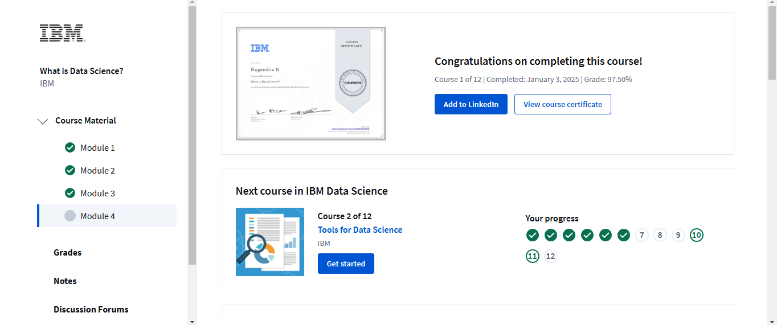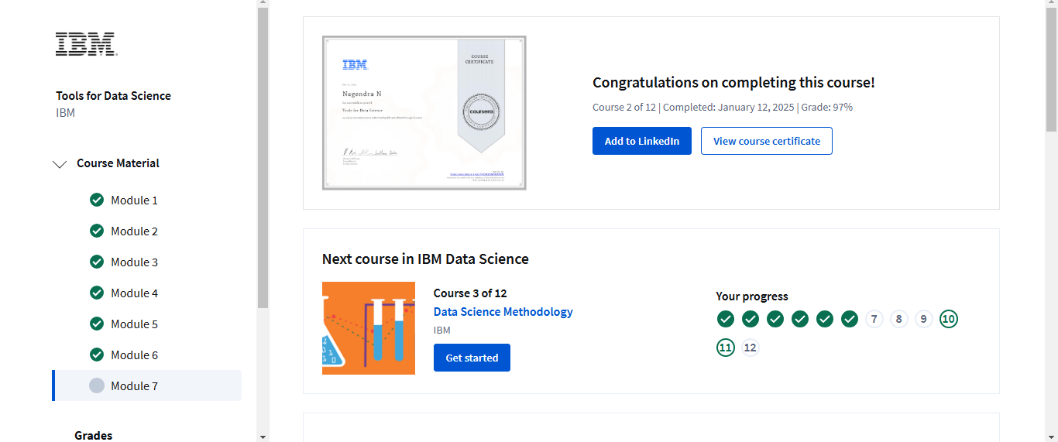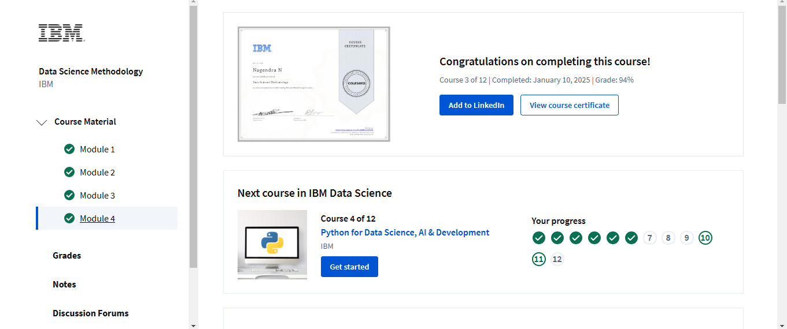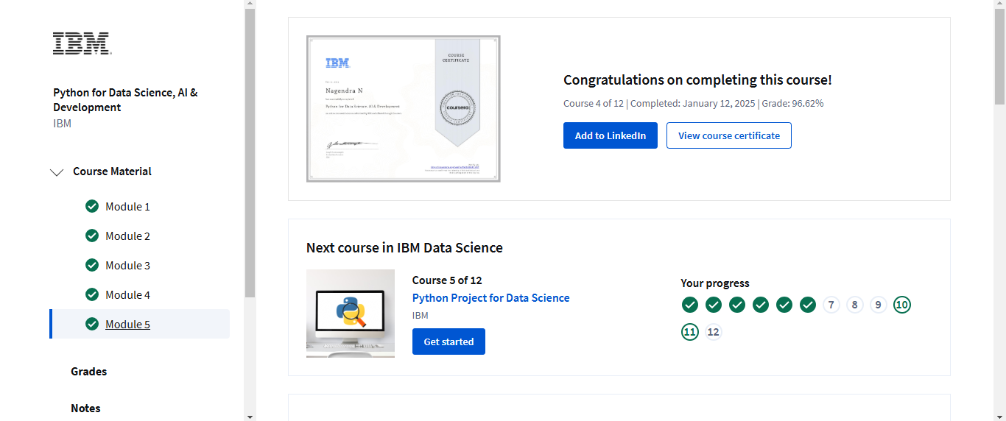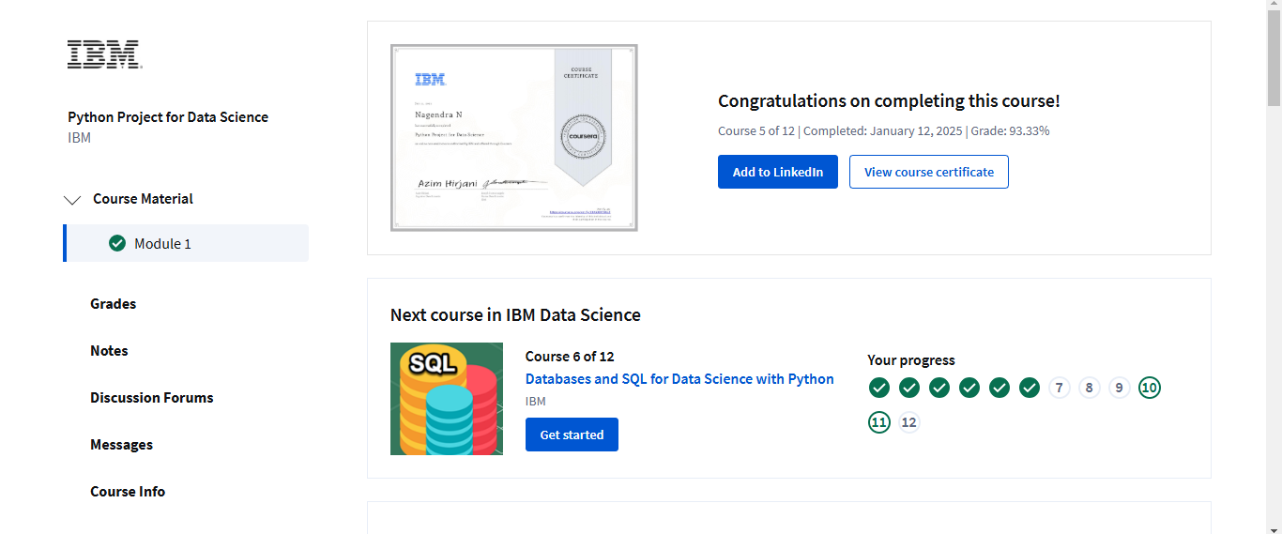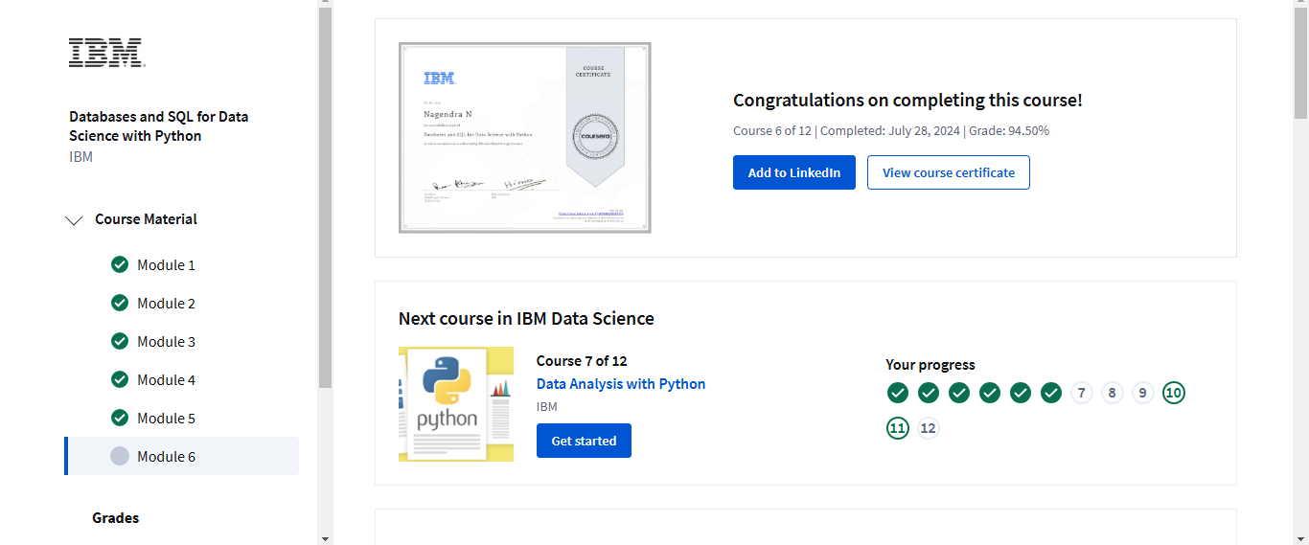

1. **Abstract of the project**

SpaceX has revolutionized the aerospace industry by introducing reusable rockets, significantly reducing the cost of space launches. The Falcon 9 rocket, a flagship of SpaceX, achieves this cost efficiency by enabling the reuse of its first stage, reducing launch expenses from $165 million to $62 million. This project aims to develop a predictive model to determine whether the Falcon 9 first stage will successfully land. Accurate predictions will provide valuable insights for potential competitors or collaborators, enabling cost estimation and strategic planning in bidding against SpaceX for rocket launches.

By utilizing data on Falcon 9 launches, including technical parameters, environmental conditions, and past outcomes, we will explore and analyse the factors influencing successful landings. Machine learning techniques will be applied to build a robust predictive model. The insights from this model will be instrumental in understanding the feasibility of reusable rocket technologies for other aerospace entities.

This project combines domain knowledge in aerospace engineering with advanced data science methodologies, offering a unique opportunity to contribute to the growing field of reusable space technologies. The outcome will not only assist in cost estimation but also encourage innovation and competition within the commercial space launch industry.

|  |
| --- |
| **Date: 12/01/2025** |
| **Student Name: Nagendra N**  **Signature:** |